Types of Grammatical Functions

✅ Main Types of Grammatical Functions:
# Source: AI Source: Provided by: [Data Path: Persons Table -> ID Column: 1, Name_En Column: Motasem Essam] -> From: [Chatgpt (GPT-4-turbo)] on [8/3/2025]
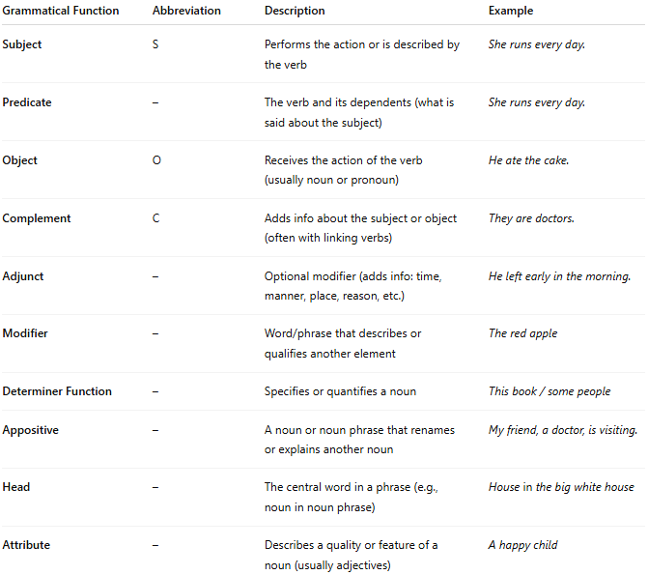

Grammatical Function | Abbreviation | Description | Example
Subject | S | Performs the action or is described by the verb | She runs every day.
Predicate | – | The verb and its dependents (what is said about the subject) | She runs every day.
Object | O | Receives the action of the verb (usually noun or pronoun) | He ate the cake.
Complement | C | Adds info about the subject or object (often with linking verbs) | They are doctors.
Adjunct | – | Optional modifier (adds info: time, manner, place, reason, etc.) | He left early in the morning.
Modifier | – | Word/phrase that describes or qualifies another element | The red apple
Determiner Function | – | Specifies or quantifies a noun | This book / some people
Appositive | – | A noun or noun phrase that renames or explains another noun | My friend, a doctor, is visiting.
Head | – | The central word in a phrase (e.g., noun in noun phrase) | House in the big white house
Attribute | – | Describes a quality or feature of a noun (usually adjectives) | A happy child

✅ Hierarchy of Functions (Phrase Level):
# Source: AI Source: Provided by: [Data Path: Persons Table -> ID Column: 1, Name_En Column: Motasem Essam] -> From: [Chatgpt (GPT-4-turbo)] on [8/3/2025]
- In a noun phrase:
  - Head: book
  - Determiner: the
  - Modifier: red
⇒ The red book
- In a clause:
  - Subject: The girl
  - Predicate: kicked the ball
⇒ The girl kicked the ball.

✅ Examples of Multiple Functions in a Sentence:
# Source: AI Source: Provided by: [Data Path: Persons Table -> ID Column: 1, Name_En Column: Motasem Essam] -> From: [Chatgpt (GPT-4-turbo)] on [8/3/2025]
"My brother gave the teacher a gift yesterday."
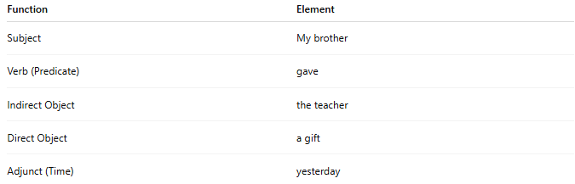
Function | Element
Subject | My brother
Verb (Predicate) | gave
Indirect Object | the teacher
Direct Object | a gift
Adjunct (Time) | yesterday

✅ Grammatical Function vs. Word Class (Category):
# Source: AI Source: Provided by: [Data Path: Persons Table -> ID Column: 1, Name_En Column: Motasem Essam] -> From: [Chatgpt (GPT-4-turbo)] on [8/3/2025]
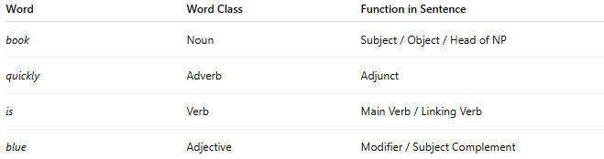
Word | Word Class | Function in Sentence
book | Noun | Subject / Object / Head of NP
quickly | Adverb | Adjunct
is | Verb | Main Verb / Linking Verb
blue | Adjective | Modifier / Subject Complement
🧠 Note: A word class is what a word is, while grammatical function is what it does in a sentence.

📝 Summary:
# Source: AI Source: Provided by: [Data Path: Persons Table -> ID Column: 1, Name_En Column: Motasem Essam] -> From: [Chatgpt (GPT-4-turbo)] on [8/3/2025]
- Grammatical functions describe how parts of a sentence behave syntactically.
- Major functions include subject, object, complement, adjunct, modifier, and determiner.
- Functions are context-based and not fixed by word class.
- Essential for syntax analysis, sentence parsing, and language teaching.

